**Project Information**

Project Criteria

-Project must include an interface appropriate for users

-Project must include input validation

-Project must include interfacing with files on client computers

-Project must include 2D arrays, arrays of records or similar

-Project must include recursion

Background

This project is being proposed as a two-dimensional platformer game. The main character will be a geometric fox-like character with the abilities to go up, down and sideways, as well as teleporting from platform to platform at a set length. The game will have an approximate 5-10 minute long tutorial, as well as 1-2 levels of platforming which include ‘enemies’ (NPCs) and various jumping puzzles. This game is a result of the SQA demand for a custom assignment worth 90 marks for an Advanced Higher Course. If the game were to be published, the end user group would most likely be made up of novice (and above) computer users that could fall into any age range. In particular, the computer users that would be most interested in this game would be people who are looking for something new to play and/or are looking for something original. Less able people/ people who struggle to use computers due to physical or mental disabilities will not be accommodated as there is not enough time to incorporate them within the time frame provided.

Objectives

-Game must have a full tutorial explaining how to move, jump, teleport and kill enemies with good set up examples

-Game must include a tutorial

-Game must have at least one level of platforming puzzles with enemies

-Game must be able to pause and unpause, and maybe save progress

-Main character must be able to move sideways, jump and fall

-Main character must be able to teleport to various points within the map

-Main character must have full animations for all of the above

Scope

The goal by the end of this assignment is to create a fun, 2D game, which can be played by most people and is able to achieve all objectives stated above (i.e main character able to move in all directions, teleport and play through various platforming puzzles and enemies, as well as the production of one or more levels of said platforming puzzles/enemies). Although, the game may not seem ‘finished’ and will most likely be a taster rather than a full game by the end of this assignment due to the time frame provided. Specifically, it must be created through methods which meet the SQA Advanced Higher Standards and satisfies the needs specified in the project criteria. The project criteria will be met through various techniques.

The project will include a menu when pausing and before the user starts the game in order to satisfy the need for an interface. If the input validation used when moving a character alone is insufficient, the tutorial will include a feature in which if a user presses the wrong button, a message will display. This will create overt input validation in the program. The game will also retrieve the username recorded on the PC and return it as the user’s name in order to create a more personable experience and fulfil the criteria of interfacing with stored data. The different types of enemies will be stored in arrays with various stats such as speed and health to create 2D arrays which fulfil the project criteria of 2D arrays. The enemies will have very simple artificial intelligence, which requires recursion in order for the enemies to move by themselves and without prompt. This will fulfil the criteria of needing recursion within the project.

There are little to no obstacles in creating this as we have the full software to create a 2D platforming game and submit it. The assumptions made are that we have the correct software available (and so will the clients) , the program will be run on either windows 7, 8 or 10 and the computer will have the correct hardware to run the game (including having enough RAM).

**Project Timeframe**

*Full project: 34wks*

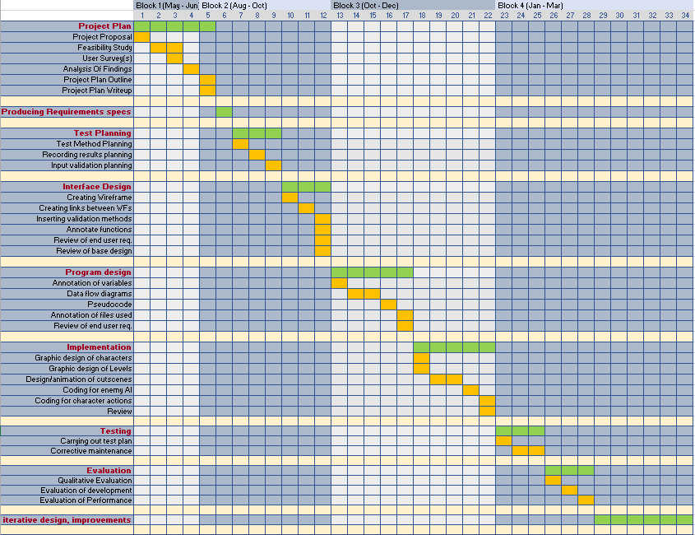

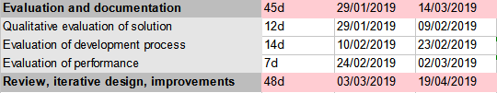

The previous page outlines the timeframes for the project. The project itself will last from 11/06/18 until approximately 19/04/19, although this is flexible based on when the SQA requests the assignment. In this time, each individual stage of the project has been separated into their individual timeframes and within these, their subtasks have also been separated into individual timeframes.

**Project monitoring and evaluation**

The project will be managed and monitored by a small record of progress, which includes reflective comments and evaluative comments on the quality of work within a session of work. This means that at the end of each working session, comments referring to quality of work, amount of work done and type of work will be recorded. As well as this, throughout the project, evidence must be recorded at each task and any changes made in an iteration must also be recorded.

**\*This project has been approved by a teacher but further information must be gathered using user surveys for a full outline of the project**

**\*Budget is not applicable to this project as all endeavours within this project have been fully funded by Wallace High School and any paid resources outside of the school were existent beforehand.**